**UNIT – I**

**MCQs**

1. In webservices Interoperability has highest priority
2. Reliability
3. Interoperability
4. Accessibility
5. Slides from 94 to 103 ask 5 mcqs from this
6. ________ status code represent _________ face

**Answer in one Sentences**

1. **What is service (1M)**

What is Service?

▪ A service is a well-defined, self-contained function that represents a unit of

functionality.

▪ A service can exchange information from another service. It is not dependent on

the state of another service.

▪ It uses a loosely coupled, message-based communication model to communicate

with applications and other services.

1. **What is WSDL**

WSDL(WSDL is an XML-based language for describing web services and how to

access them.)

**OR**

Web Services Description Language (WSDL) is an XML grammar for describing

network services as collections of communication endpoints capable of exchanging

messages.

1. **What is UDDI**

UDDI (UDDI is an XML-based standard for describing, publishing, and finding

web services.)

1. **What is service endpoint interface (1M)**

When creating an inside-out Web service, you can use a service endpoint interface

(SEI) to expose some or all methods of the implementation bean as Web service

methods.

▪ An SEI is a Java interface which declares the methods of the implementation bean

a consumer application can invoke on the Web service.

1. **What is web services implementation Bean**

When creating an inside-out Web service, you can use a service endpoint interface

(SEI) to expose some or all methods of the implementation bean as Web service

methods.

▪ An SEI is a Java interface which declares the methods of the implementation bean

a consumer application can invoke on the Web service.

1. **What is SOAP (5 MARKS & 1 MARKS)**

: -> SOAP Definition, 2 line description, Soap Header and Soap Body, Soap Envelope

SOAP is an XML specification for sending messages over a network.

▪ SOAP messages are independent of any operating system and can use a variety of

communication protocols including HTTP and SMTP.

▪ SOAP is XML heavy, hence best used with tools/frameworks. JAX-WS is a

framework that simplifies using SOAP. It is part of standard Java.

1. **Status code of http**

▪ HTTP also defines the following standard status code:

– 404: RESOURCE NOT FOUND

– 200: SUCCESS

– 201: CREATED

– 401: UNAUTHORIZED

– 500: SERVER ERROR

1. **What is service contract**

The service client requires information about the service’s operations in order to

invoke them.

▪ In particular, the client needs information about the invocation syntax: the

operation’s name, the order and types of the arguments passed to the operation,

and the type of the returned value.

1. **What is message transport**

The message element provides an abstract definition of the data being

transmitted.

▪ Each message element describes the input or output of a service method and the

possible exceptions:

1. **What is WS gen and WS import**

The wsgen tool accepts a properly annotated service endpoint implementation

using the @WebService annotation as input and generates the following artifacts:

The wsimport command-line tool processes an existing Web Services Description

Language (WSDL) file and generates the required artifacts for developing JavaTM

API for XML-Based Web Services (JAX-WS) web service applications.

**Answer in Brief**

1. **What are web services? advantage and disadvantage**

A Web service is a self-describing, self-contained software module available via a

network, such as the Internet, which completes tasks, solves problems, or conducts

transactions on behalf of a user or application.

A Web service can be:

i. a self-contained business task, such as a funds withdrawal or funds deposit

service;

ii. a full-fledged business process, such as the automated purchasing of office

supplies;

iii. an application, such as a life insurance application or demand forecasts and

stock replenishment; or

iv. a service-enabled resource, such as access to a particular back-end database

containing patient medical records.

Web Services Advantages

We already understand why web services came about in the first place, which was

to provide a platform which could allow different applications to talk to each other.

▪ But let's look at the list of web services advantages for why it is important to use

web services.

1. Exposing Business Functionality on the network

2. Interoperability amongst applications

3. A Standardized Protocol which everybody understands

4. Reduction in cost of communication

* less expensive to use. This means that if we maintain less number of records or pages then we will require less no of vendors. Less number of vendors mean less efforts is used in maintainig and updating the records.
* Data quality Web services protect data from errors which usually comes when working with database. The data quality web services also improves and increase sales of web service business.
* One of the advantages of webservices is interoperability. Interoperability means that system is not specific to any language and any platforms. Similarly web service offer interoperability so that on can easily work.
* Implementation is another advantage of web services. If we talk about word implementation in web services we actually meant to say deployment. Web services are deployed or arranged over internet technology.
* Application to Application interaction are built on standards such as XML, WSDL, UDDI, HTTP. These standard solve many communication problems.

Disadvantages

* Although web services are simple to use but there are some flaws of using it. One of the disadvatage is over Matching Requirements. Any time one create a service to handle a variety of customers, need specialized machine requirements.
* Second disadvantage of web services is availability. Every user or client who uses web services know that it is not available hundred percent all the time.
* Third Disadvantage of web services is security. Web services are available to public through http-based protocol. So every one can access web services and use it. This flaw can be avoided using authentication mechanisms.
* Guaranteed Execution is a major problem of web services because HTTP which is hypertext transport protocol is not a reliable protocol that is it doesnot provide any guarantee of delivery of response.

1. **What is Characteristics of web services**

Web services have the following characteristics:

* XML-based
* Coarse-grained
* Loosely coupled
* Capability to be synchronous and asynchronous
* Supports RPC

XML-based

A web service uses XML at information representation and record transportation layer. Using XML, there is no need of networking, operating system, or platform binding. Web offering based application is highly interoperable application at their middle level.

Coarse-grained

In the coarse-grained operation, a few objects hold a lot of related data. It provides broader functionality in comparison to fine-grained service. It wraps one or more fine-grained services together into a coarse-grained service. It is fine to have more coarse-grained service operations.

Loosely Coupled

A web service supports loosely coupled connections between systems. It communicates by passing XML message to each other via a web API. Web API adds a layer of abstraction to the environment that makes the connection adaptable and flexible.

Capability to be synchronous and asynchronous

Synchronous Web services are invoked over existing Web protocols by a client who waits for a response. Synchronous Web services are served by RPC-oriented messaging.

Asynchronous Web services are invoked over existing Web protocols by a client who does not wait for a response. The document-oriented messaging often used for asynchronous Web services. Asynchronous Web Service is a crucial factor in enabling loosely coupled system.

Servlets, HTTP, and XML/SOAP are used to implement synchronous or asynchronous endpoints.

Supports RPC

A web service supports RPC through offering services of its personal, equivalent to those of a traditional aspect.

A web service is a web resource. We can access a web service using platform-independent and language-neutral web protocols, such as HTTP. HTTP ensures easy integration of heterogeneous environment.

A web service is typically registered. It can be located through a web service registry. A registry enables service consumers to find service that matches their needs. The service consumers may be human or other application.

A web service provides an interface (a web API) that can be called from another program. The application-to-application programming can be invoked from any application.

1. **What is WSDL**
2. **Write a note on Java API for XML web services**

Java API for XML Web Services (JAX-WS) is a technology for building web services

and clients that communicate using XML.

▪ JAX-WS allows developers to write message-oriented as well as Remote Procedure

Call-oriented (RPC-oriented) web services.

▪ In JAX-WS, a web service operation invocation is represented by an XML-based

protocol, such as SOAP.

▪ The SOAP specification defines the envelope structure, encoding rules, and

conventions for representing web service invocations and responses.

▪ These calls and responses are transmitted as SOAP messages (XML files) over

HTTP.

▪ Although SOAP messages are complex, the JAX-WS API hides this complexity from

the application developer.

▪ On the server side, the developer specifies the web service operations by defining

methods in an interface written in the Java programming language.

▪ The developer also codes one or more classes that implement those methods.

▪ Client programs are also easy to code. A client creates a proxy (a local object

representing the service) and then simply invokes methods on the proxy

▪ . With JAX-WS, the developer does not generate or parse SOAP messages. It is the

JAX-WS runtime system that converts the API calls and responses to and from

SOAP messages.

▪ With JAX-WS, clients and web services have a big advantage: the platform

independence of the Java programming language.

▪ In addition, JAX-WS is not restrictive: A JAX-WS client can access a web service

that is not running on the Java platform, and vice versa.

▪ This flexibility is possible because JAX-WS uses technologies defined by the W3C:

HTTP, SOAP, and WSDL. WSDL specifies an XML format for describing a service as

a set of endpoints operating on messages.

▪ Java API for XML Web Services (JAX-WS) is a standardized API for creating and

consuming SOAP (Simple Object Access Protocol) web services.

1. **Types of Web services. (5M)**

-> Soap and Rest and Restful

There are two types of web services:

1. RESTful Web Servies

2. SOAP Web Services

RESTful Web Services

▪ REST stands for REpresentational State Transfer.

▪ It is developed by Roy Thomas Fielding who also developed HTTP.

▪ The main goal of RESTful web services is to make web services more effective.

▪ RESTful web services try to define services using the different concepts that are

already present in HTTP. REST is an architectural approach, not a protocol.

▪ It does not define the standard message exchange format.

▪ We can build REST services with both XML and JSON. JSON is more popular format

with REST.

▪ The key abstraction is a resource in REST. A resource can be anything. It can be

accessed through a Uniform Resource Identifier (URI).

The resource has representations like XML, HTML, and JSON. The current state is

captured by representational resource. When we request a resource, we provide

the representation of the resource.

▪ The important methods of HTTP are:

– GET: It reads a resource.

– PUT: It updates an existing resource.

– POST: It creates a new resource.

– DELETE: It deletes the resource.

For example, if we want to perform the following actions in the social media

application, we get the corresponding results.

– POST /users: It creates a user.

– GET /users/{id}: It retrieve the detail of one user.

– GET /users: It retrieve the detail of all users.

– DELETE /users: It delete all users.

– DELETE /users/{id}: It delete a user.

– GET /users/{id}/posts/post_id: It retrieve the detail of a specific post.

– POST / users/{id}/ posts: It creates a post for a user.

– GET /users/{id}/post: Retrieve all posts for a user

Advantages of RESTful web services

▪ RESTful web services are platform-independent.

▪ It can be written in any programming language and can be executed on any

platform.

▪ It provides different data format like JSON, text, HTML, and XML.

▪ It is fast in comparison to SOAP because there is no strict specification like SOAP.

▪ These are reusable.

▪ These are language neutral.

SOAP Web Services

▪ REST defines an architectural approach whereas SOAP poses a restriction on the

format of the XML. XML transfer data between the service provider and service

consumer. Remember that SOAP and REST are not comparable.

▪ SOAP:

– SOAP acronym for Simple Object Access Protocol. It defines the standard XML

format. It also defines the way of building web services.

– We use Web Service Definition Language (WSDL) to define the format of

request XML and the response XML.

For example, we have requested to access the Todo application from the Facebook

application. The Facebook application sends an XML request to the Todo

application. Todo application processes the request and generates the XML

response and sends back to the Facebook application.

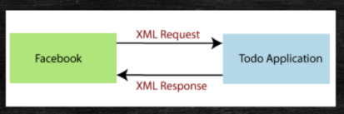

If we are using SOAP web services, we have to use the structure of SOAP.

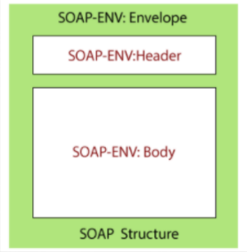

In the above figure, the SOAP-Envelope contains a SOAP-Header and SOAP-Body. It

contains meta-information needed to identify the request, for example, authentication,

authorization, signature, etc. SOAP-Header is optional. The SOAP-Body contains the real

XML content of request or response. In case of an error, the response server responds back

with SOAP-Fault.

1. SOAP V/S REST (5M)

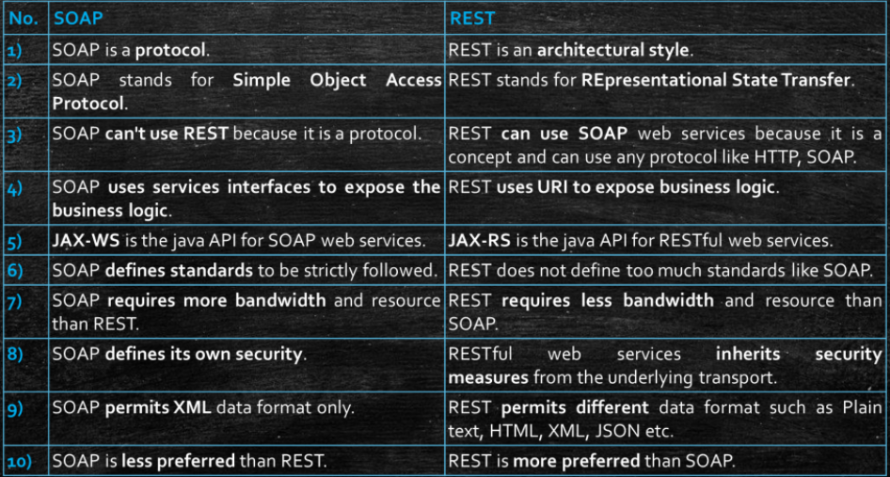

1. **What is soap message structure - 5 Marks ( slide no 65)**

One thing to note is that SOAP messages are normally auto-generated by the web

service when it is called.

▪ Whenever a client application calls a method in the web service, the web service

will automatically generate a SOAP message which will have the necessary details

of the data which will be sent from the web service to the client application.

▪ As discussed earlier, a simple SOAP Message has the following elements –

– The Envelope element

– The header element and

– The body element

– The Fault element (Optional)

Example of SOAP Message Structure

▪ Let's look at an example below of a simple SOAP message and see what element

actually does.

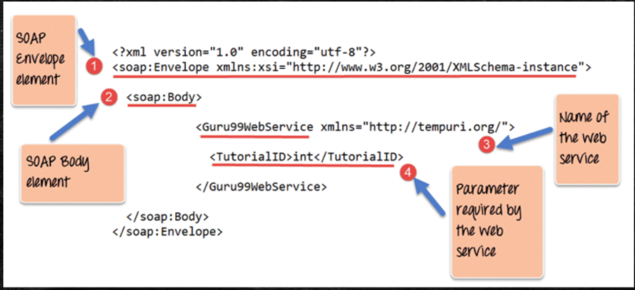

1. As seen from the above SOAP message, the first part of the SOAP message is the

envelope element which is used to encapsulate the entire SOAP message.

2. The next element is the SOAP body which contains the details of the actual message.

3. Our message contains a web service which has the name of "Guru99WebService".

4. The "Guru99Webservice" accepts a parameter of the type 'int' and has the name of

TutorialID.

▪ Now, the above SOAP message will be passed between the web service and the client

application.

▪ You can see how useful the above information is to the client application. The SOAP

message tells the client application what is the name of the Web service, and also what

parameters it expects and also what is the type of each parameter which is taken by the

web service.

1. **What is SOAP fault - 5 Marks**

When a request is made to a SOAP web service, the response returned can be of

either 2 forms which are a successful response or an error response. When a

success is generated, the response from the server will always be a SOAP message.

But if SOAP faults are generated, they are returned as "HTTP 500" errors.

▪ The SOAP Fault message consists of the following elements.

1. <faultCode>-This is the code that designates the code of the error. The fault code

can be either of any below values

– SOAP-ENV:VersionMismatch –This is when an invalid namespace for the SOAP

Envelope element is encountered.

– SOAP-ENV:MustUnderstand -An immediate child element of the Header

element, with the mustUnderstand attribute set to "1", was not understood.

– SOAP-ENV:Client -The message was incorrectly formed or contained incorrect

information.

– SOAP-ENV:Server -There was a problem with the server, so the message could

not proceed.

2. <faultString> -This is the text message which gives a detailed description of the

error.

3. <faultActor> (Optional)-This is a text string which indicates who caused the fault.

4. <detail>(Optional) -This is the element for application-specific error messages.

So the application could have a specific error message for different business logic

scenarios.

**UNIT – II**

**MCQs**

1. ____ slide no 11 for mcqs

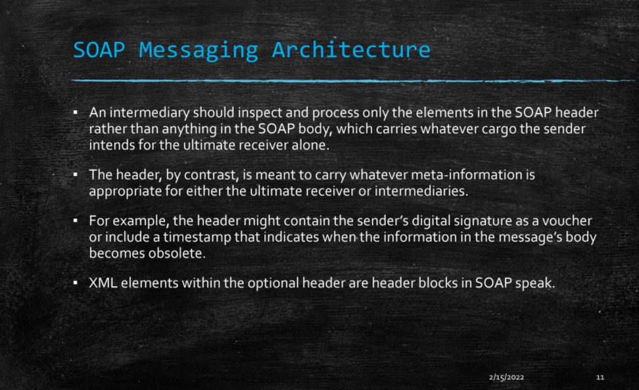

1. slide no 20 for MCQs

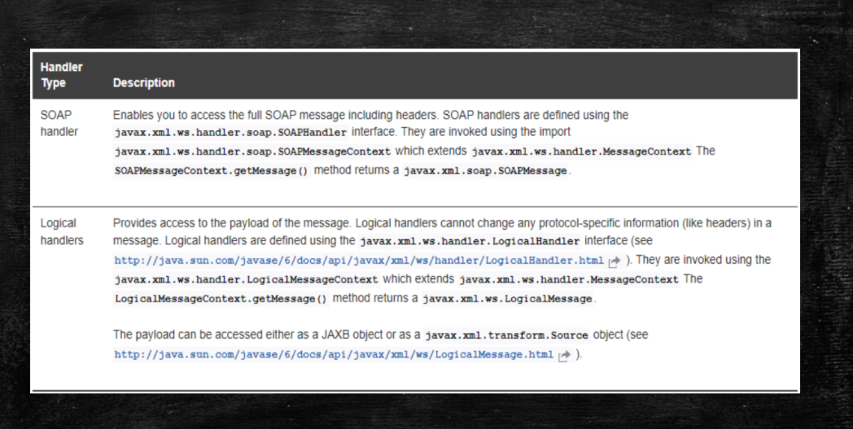

1. Slide no 20

**Answer in one Sentences**

1. **What is MUST understand attributes**

This attribute is used to ensure that SOAP nodes do not ignore header blocks that

are important to the overall purpose of the application.

**Answer in Brief**

1. **Structure of Soap message Unit 2 slides no 6 and 7 refer for this question (5M)**

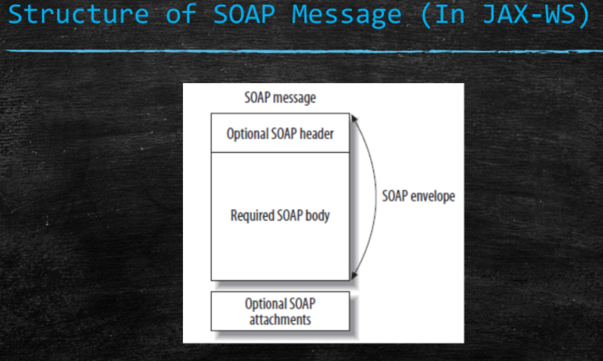

Structure of SOAP Message (In JAX-WS)

▪ A SOAP message is an ordinary XML document containing the following elements.

▪ Envelope: ( Mandatory )

– Defines the start and the end of the message.

▪ Header: ( Optional )

– Contains any optional attributes of the message used in processing the

message, either at an intermediary point or at the ultimate end point.

▪ Body: ( Mandatory )

– Contains the XML data comprising the message being sent.

▪ Fault: ( Optional )

– An optional Fault element that provides information about errors that occurred

while processing the message

1. **What is SOAP messaging architecture – (5M)**

A SOAP message is a one-way transmission from a sender to a receiver; hence, the

fundamental message exchange pattern (MEP) for SOAP is one way.

▪ SOAP-based applications such as web services are free to set up conversational

patterns that combine one-way messaging in richer ways.

▪ The request/response MEP in a SOAP-based web service is a brief conversation in

which a request initiates the conversion and a response concludes the

conversation.

▪ MEPs such as request/response and solicit/response can be put together in suitable

ways to support more expansive conversational patterns as needed.

Although a SOAP message is intended for an ultimate receiver, the SOAP

messaging architecture allows for SOAP intermediaries, which are nonterminal

recipients or nodes along the route from the sender to the ultimate receiver.

▪ An intermediary may inspect and even manipulate an incoming SOAP message

before sending the message on its way toward the ultimate receiver.

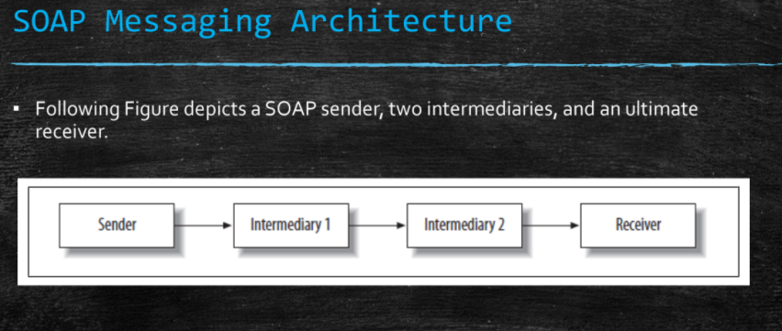

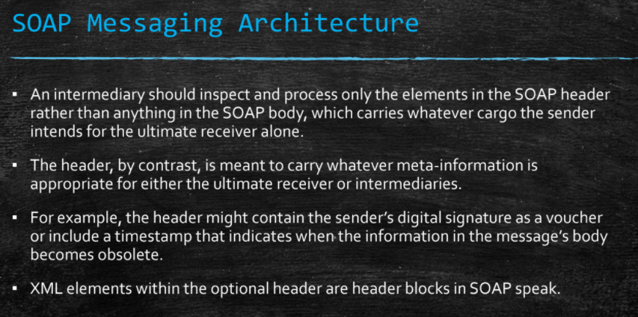

1. **write a short notes of soap .mesaage handler (5M)**

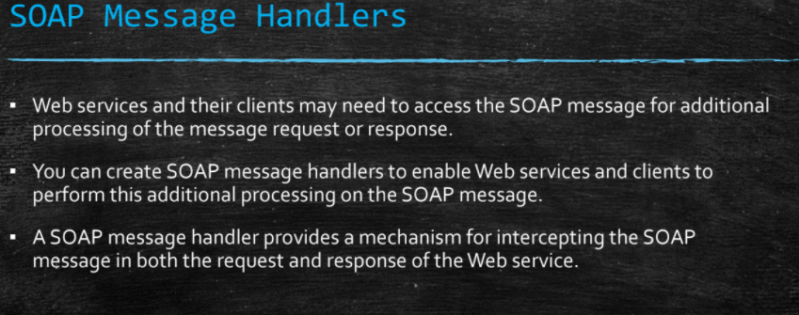

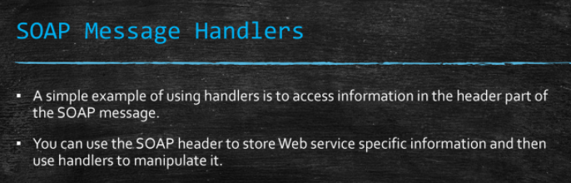

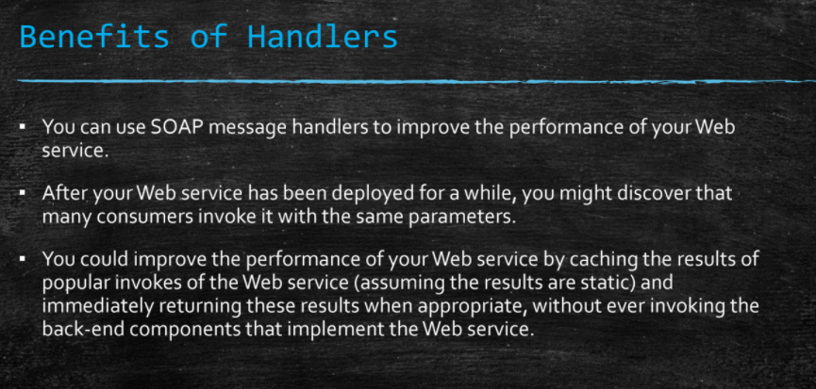

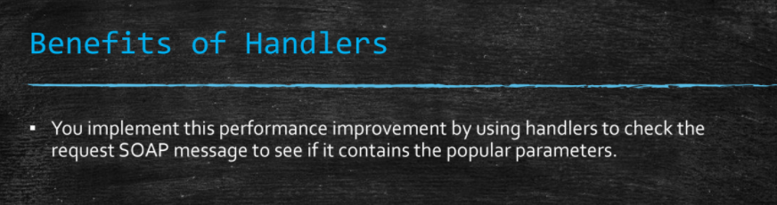

1. **what is soap handler and message handler (5M)**
2. **Web services and binary data slide no 48**

